Name: PRATIK SUNIL ABHANG
Registration ID: 260640160209
Question:
Q1. Display System Information

Program
#!/bin/bash
echo "Welcome to Linux"
echo "Current Username : $USER"
echo "Current Working Directory : $(pwd)"
echo "Current Date and Time : $(date)"

Commands
nano q1.sh
cat q1.sh
bash q1.sh

Input and Output
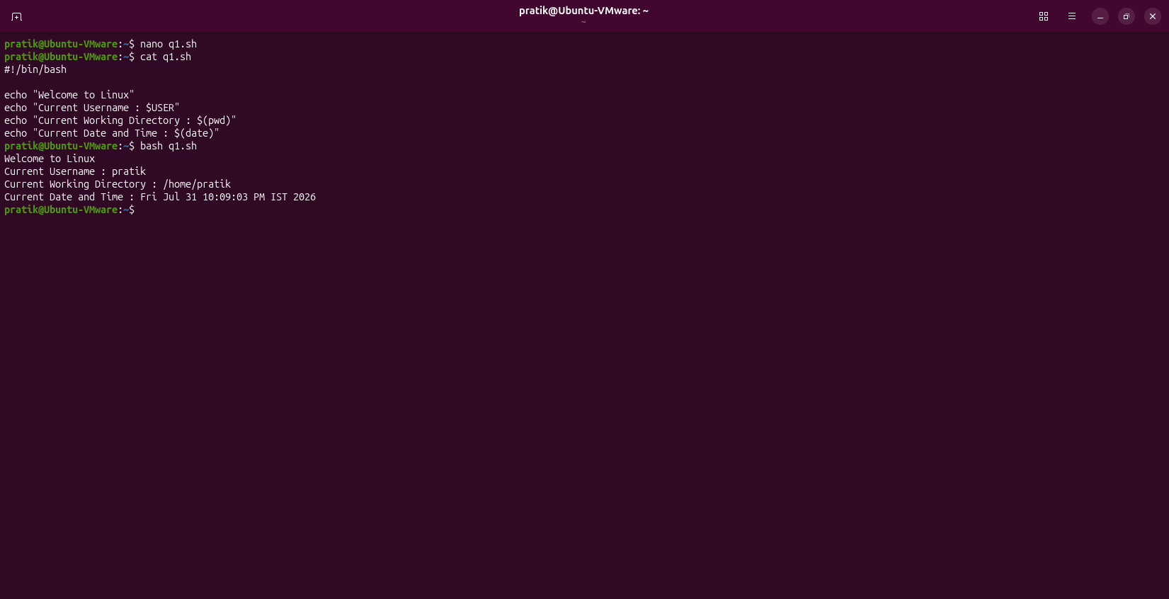

Question:
Q2. Display Environment Variables

Program
#!/bin/bash
echo "Home Directory: $HOME"
echo "Shell Name: $SHELL"
echo "Username: $USER"
echo "Hostname: $(hostname)"

Commands
nano q2.sh
cat q2.sh
bash q2.sh

Input and Output
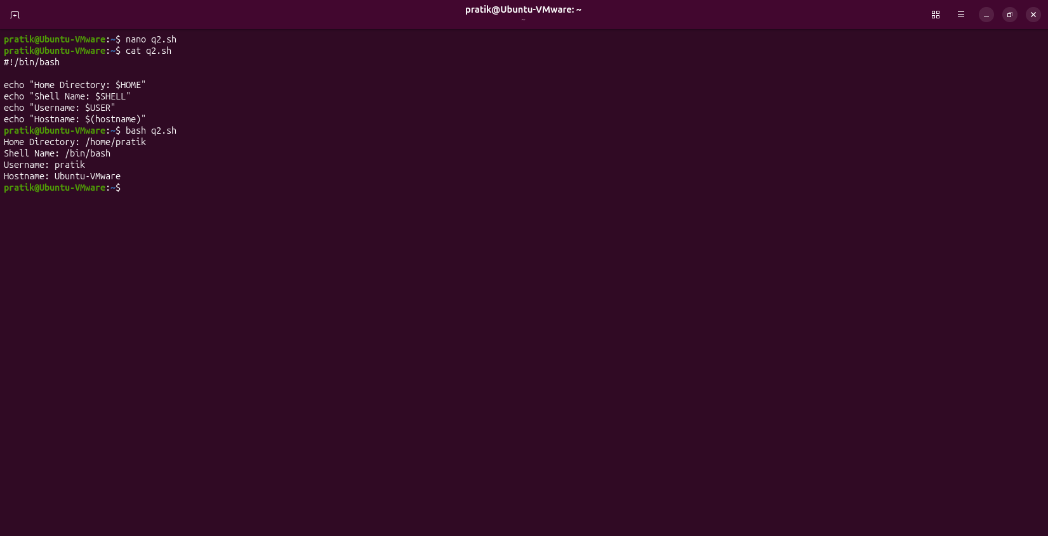

Question:
Q3. Read User Information

Program
#!/bin/bash
read -p "Enter Name: " name
read -p "Enter City: " city
echo "Hello $name"
echo "Welcome from $city"

Commands
nano q3.sh
cat q3.sh
bash q3.sh

Input and Output
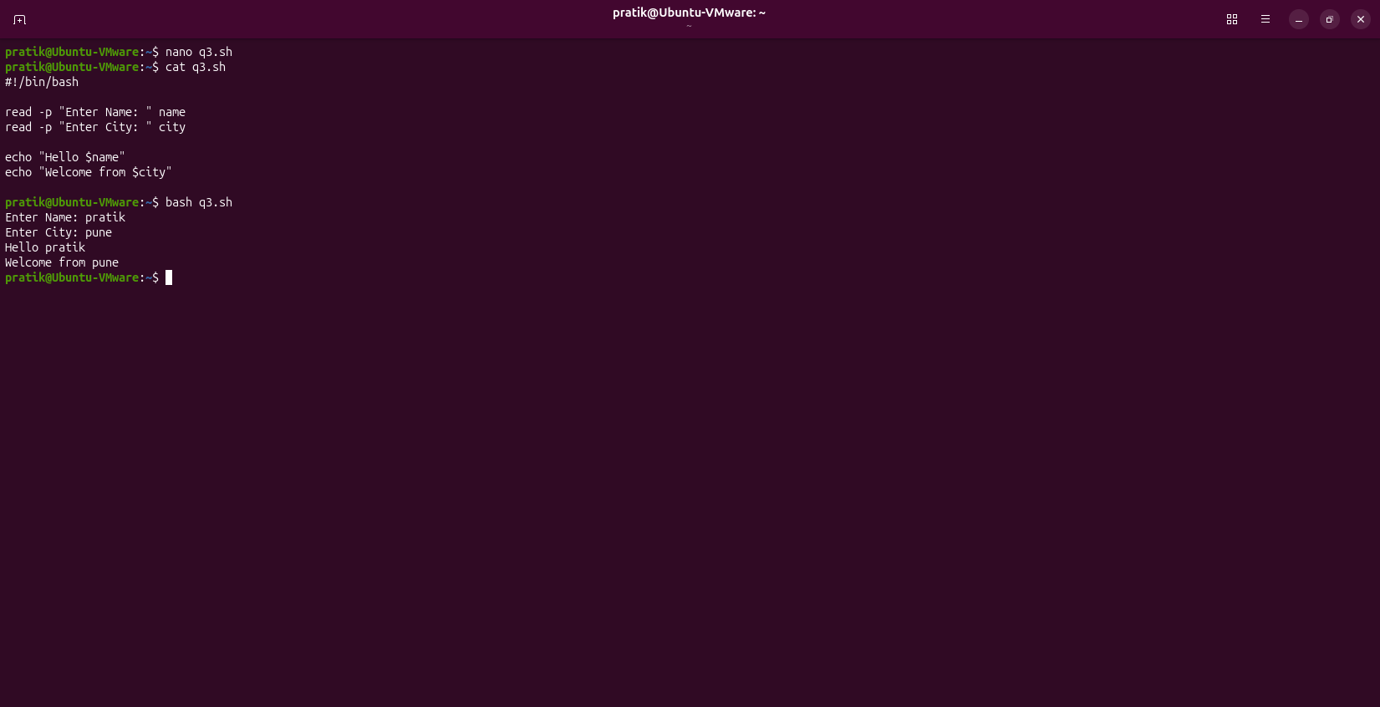

Question:
Q4. Display Contents of a File

Program
#!/bin/bash
read -p "Enter Filename: " file
cat "$file"

Commands
nano q4.sh
cat q4.sh
bash q4.sh

Input and Output
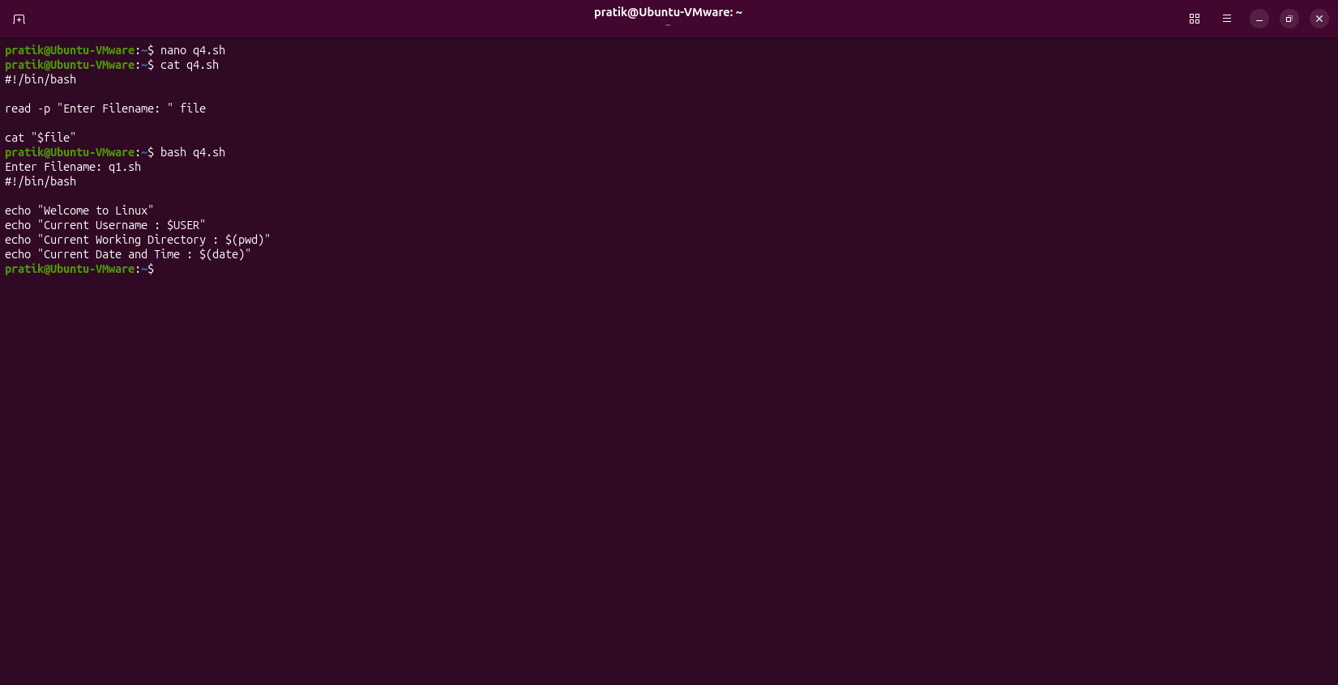

Question:
Q5. Count Lines in a File

Program
#!/bin/bash
read -p "Enter Filename: " file
wc -l < "$file"

Commands
nano q5.sh
cat q5.sh
bash q5.sh

Input and Output
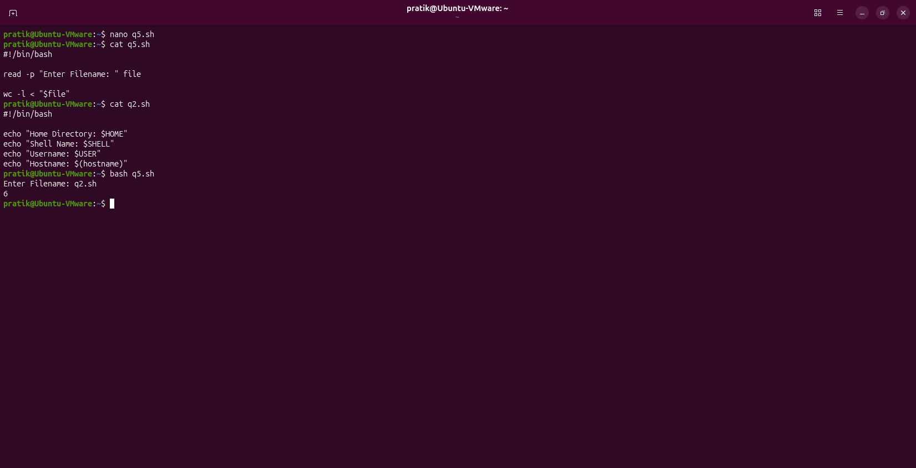

Question:
Q6. Search a Word in a File

Program
#!/bin/bash
read -p "Enter Filename: " file
read -p "Enter Search Word: " word
grep "$word" "$file"

Commands
nano q6.sh
cat q6.sh
bash q6.sh

Input and Output
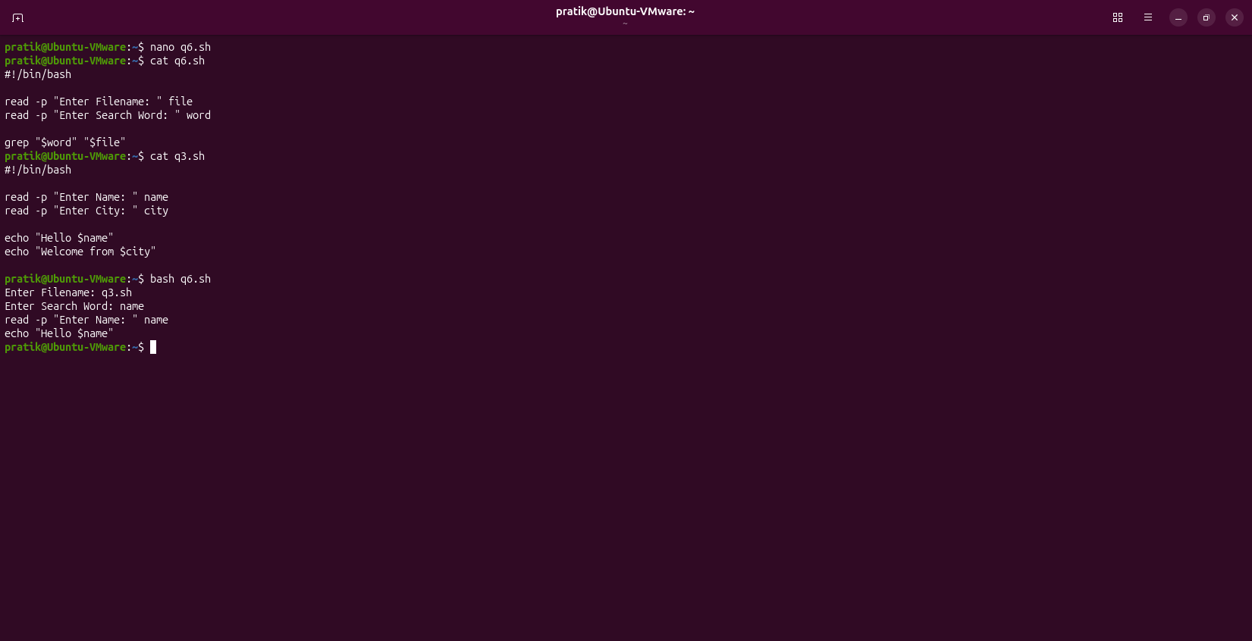

Question:
Q7. List Directory Contents

Program
#!/bin/bash
read -p "Enter Directory Path: " dir
ls -l "$dir"

Commands
nano q7.sh
cat q7.sh
bash q7.sh

Input and Output
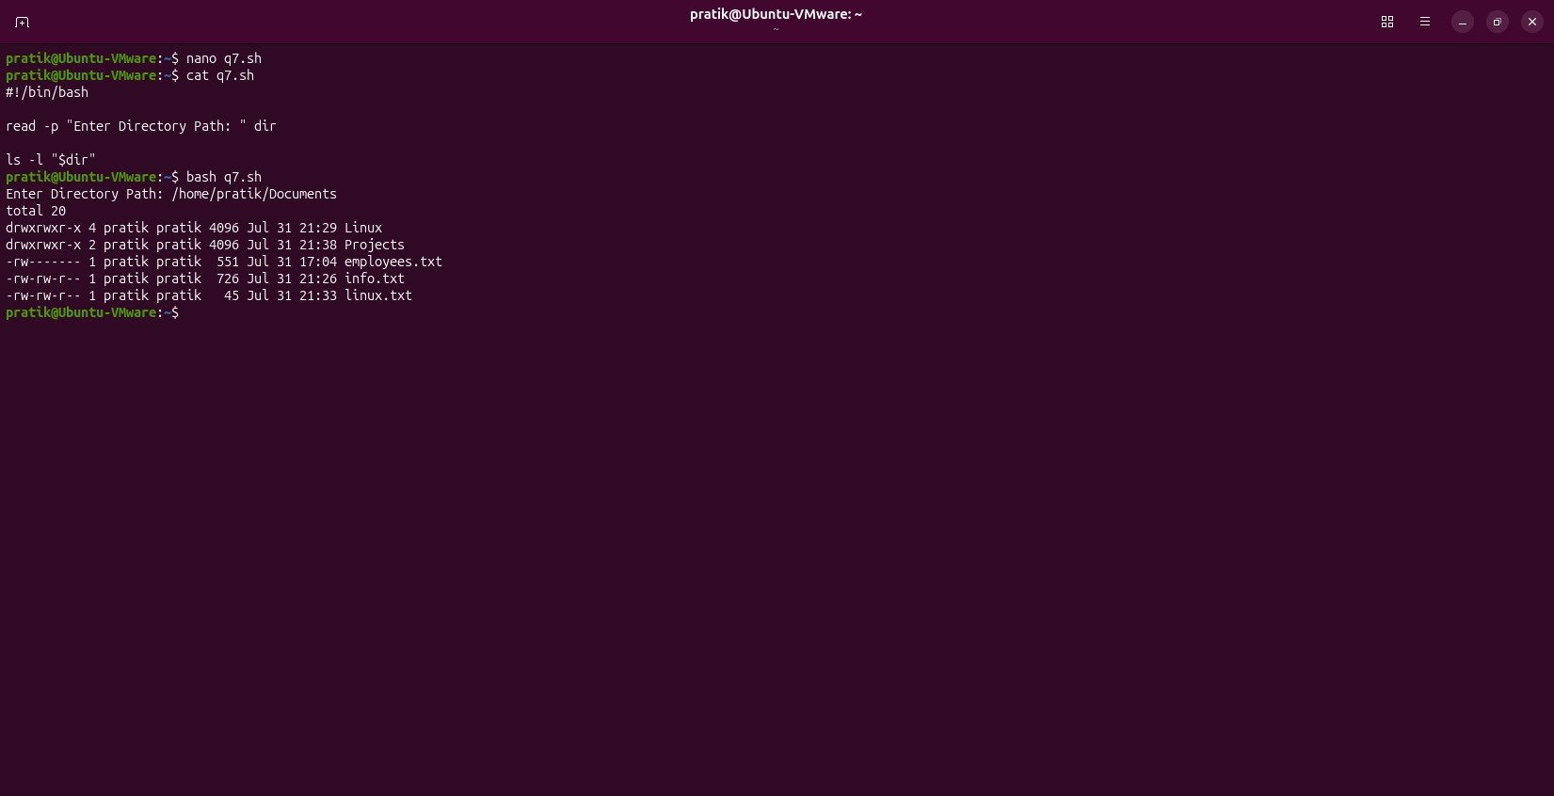

Question:
Q8. Display File with Line Numbers

Program
#!/bin/bash
echo "Enter Filename:"
read file
nl "$file"

Commands
nano q8.sh
cat q8.sh
bash q8.sh

Input and Output
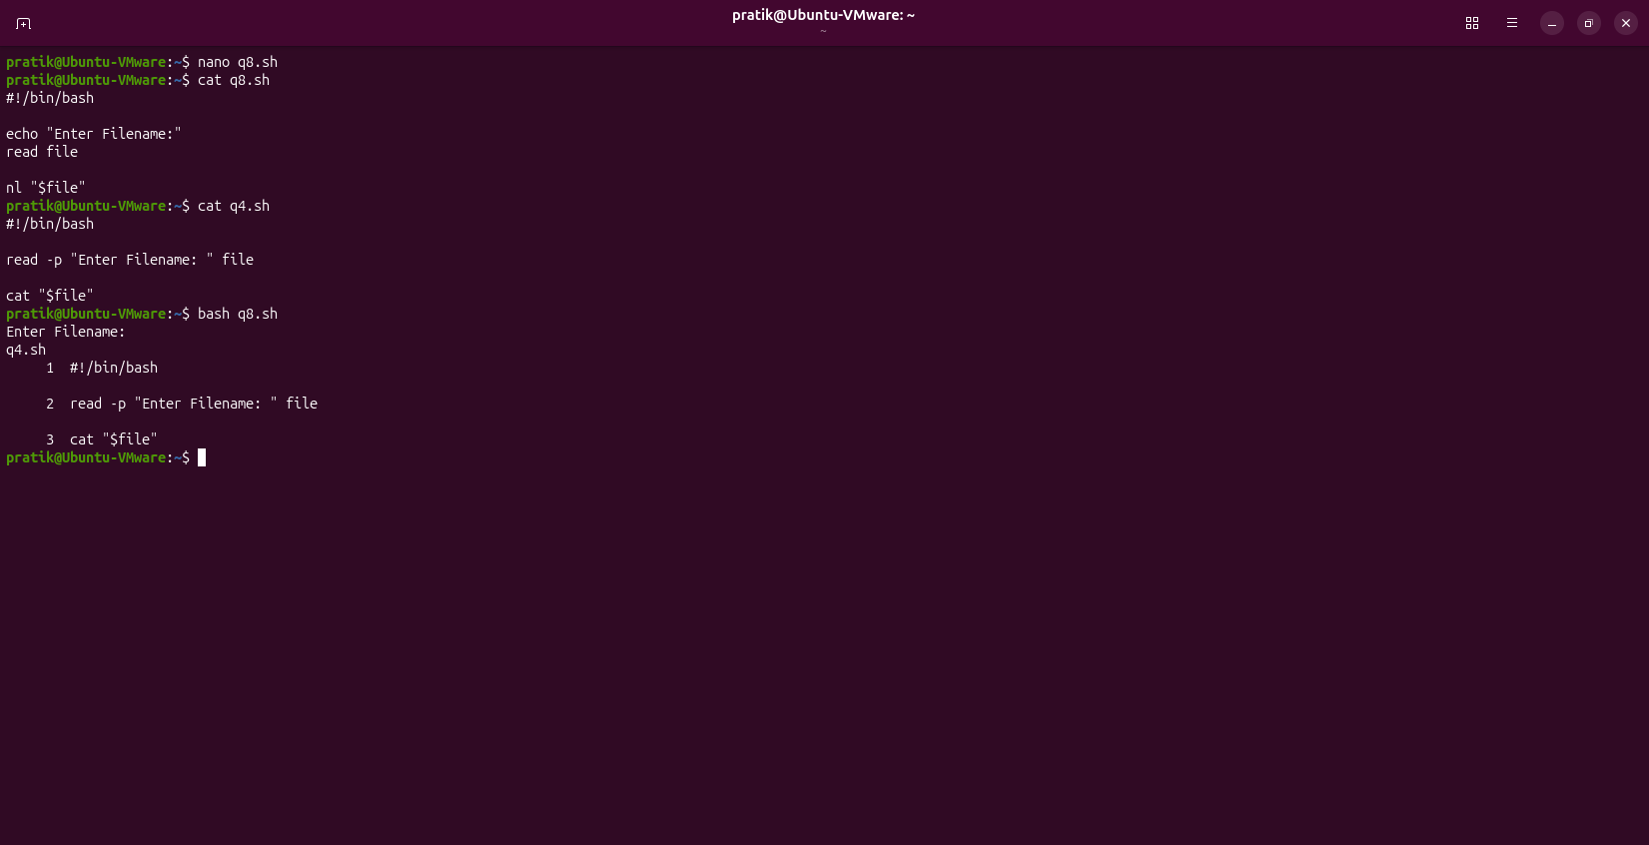

Question:
Q9. Display Command Output in a File

Program
#!/bin/bash
echo "Current Date: $(date)" > systeminfo.txt
echo "Current Working Directory: $(pwd)" >> systeminfo.txt
echo "Logged-in Username: $USER" >> systeminfo.txt
echo "Contents of systeminfo.txt"
cat systeminfo.txt

Commands
nano q9.sh
cat q9.sh
bash q9.sh

Input and Output
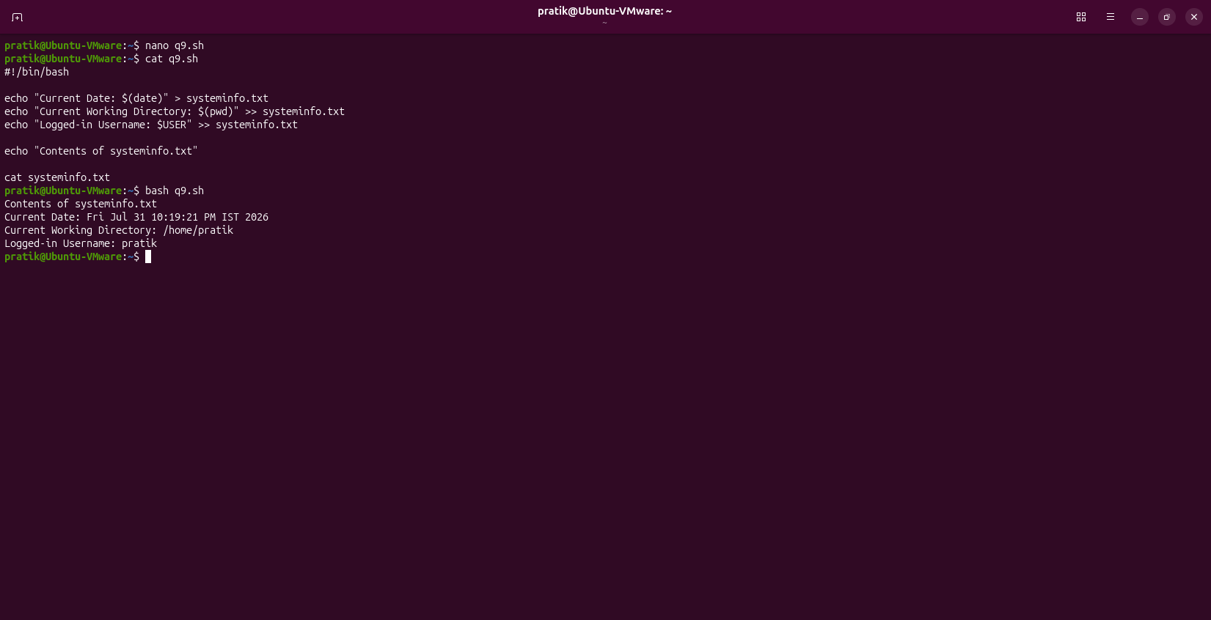

Question:
Q10. Multiple Commands in One Script

Program
#!/bin/bash
echo "Current Directory:"
pwd
echo "Files Including Hidden:"
ls -la
echo "Environment Variables:"
printenv
echo "Script Executed Successfully"

Commands
nano q10.sh
cat q10.sh
bash q10.sh

Input and Output
